Round Table Forum
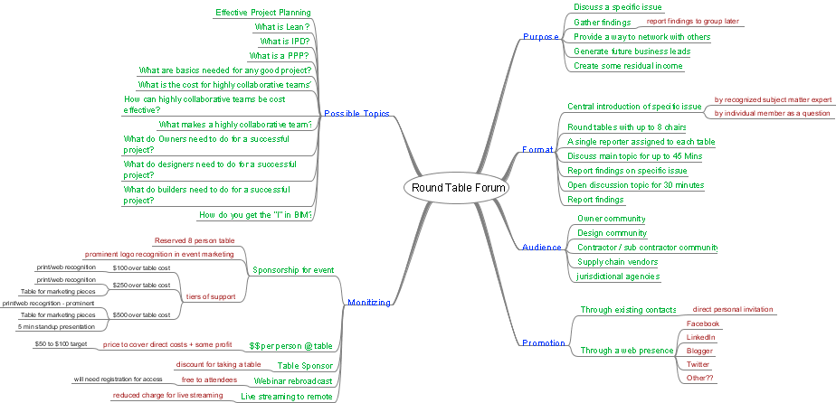

Purpose

Discuss a specific issue

Gather findings

report findings to group later

Provide a way to network with others

Generate future business leads

Create some residual income

Format

Central introduction of specific issue

by recognized subject matter expert

by individual member as a question

Round tables with up to 8 chairs

A single reporter assigned to each table

Discuss main topic for up to 45 Mins

Report findings on specific issue

Open discussion topic for 30 minutes

Report findings

Audience

Owner community

Design community

Contractor / sub contractor community

Supply chain vendors

jurisdictional agencies

Possible Topics

Effective Project Planning

What is Lean?

What is IPD?

What is a PPP?

What are basics needed for any good project?

What is the cost for highly collaborative teams?

How can highly collaborative teams be cost effective?

What makes a highly collaborative team?

What do Owners need to do for a successful project?

What do designers need to do for a successful project?

What do builders need to do for a successful project?

How do you get the "I" in BIM?

Monitizing

Sponsorship for event

Reserved 8 person table

prominent logo recognition in event marketing

tiers of support
$100 over table cost
print/web recognition
$250 over table cost
print/web recognition
Table for marketing pieces
$500 over table cost
print/web recognition - prominent
Table for marketing pieces
5 min standup presentation

$$ per person @ table

price to cover direct costs + some profit
$50 to $100 target

Table Sponsor

discount for taking a table

Webinar rebroadcast

free to attendees
will need registration for access

Live streaming to remote

reduced charge for live streaming

Promotion

Through existing contacts

direct personal invitation

Through a web presence

Facebook

LinkedIn

Blogger

Twitter

Other??

